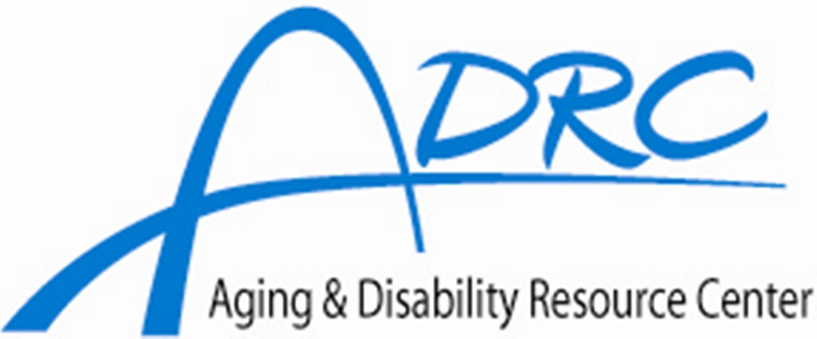
Serving Adams, Green Lake, & Waushara Counties
1-877-883-5378
ADRC Governing Board Minutes
December 12, 2019

- Certification of Open Meeting Law

- Pledge of Allegiance

- Call to Order –

- Introduction of New Members, if applicable.
- Roll Call/Mileage –
Adams: Green Lake: Waushara:
Jack Allen Joy Waterbury Warren Brewer
Marge Edwards Suzi Giesen John Jarvis
Charlie Wielgosh Linda Manske
Absent: Jack Allen, Marge Edwards, Suzi Giesen, Joy Waterbury, Charlie Wielgosh, Warren Brewer, Jerry Lauer, Linda Manske, John Jarvis
Guest(s): None
ADRC Staff: Jennifer Dille, Linda Reinholtz
A Quorum was not present due to bad weather.
- Adoption of the Agenda:

- Approval of Minutes of the Previous Meeting:

- Public Comment (3 minutes/person, maximum of 15 minutes):

- REPORTS:

- ADRC Local Activities (Jennifer Dille):

State Activity (Jennifer Dille):

- Advocacy Update:

- OLD BUSINESS:

- NEW BUSINESS:

- MEETING DATE & LOCATION/SUGGESTIONS FOR FUTURE AGENDA ITEMS: The next meeting is
scheduled for March 12, 2020 in the Waushara County Demonstration Room at 1:00 PM.

XIII. ADJORNMENT:

Respectfully Submitted
Linda Reinholtz, Administrative Assistant
Waushara County Aging & Disability Resource Center

