No. 2019-248
(Assigned by County Clerk)

PUBLIC NOTICE – ___________
Meeting of ADRC GOVERNING BOARD
AGING & DISABILITY RESOURCE CENTER
SERVING ADAMS, GREEN LAKE, and WAUSHARA COUNTIES

Purpose of Meeting: Regular Distribution:
Date: Thursday December 12, 2019 1. Press
Time: 1:00 pm 2. Posted
Place: Waushara County Court House 3. Minutes Book Originator
209 S. Ste Marie St.
Demonstration Room
Wautoma, WI

Agenda

- CERTIFICATION OF OPEN MEETING LAW
- PLEDGE OF ALLIGIANCE
- CALL TO ORDER
- INTRODUCTION OF NEW MEMBERS, if applicable
- ROLL CALL/MILEAGE

ADOPTION OF THE AGENDA
- APPROVAL OF MINUTES OF THE PREVIOUS MEETING
- PUBLIC COMMENTS (3 Minutes/Person, Maximum 15 Minutes)
- REPORTS
  - ADRC Local Activity
    - Staffing updates
    - Dementia Live Experience

  - State Activity

ADRC directors meeting updates

  - Advocacy update

OLD BUSINESS
  - 2020 Budget discussion

NEW BUSINESS
A. Approval of Resolution to change Fiscal Agent

MEETING DATE & LOCATION / SUGGESTION FOR FUTURE AGENDA ITEMS

File and posted in the Office of the County Clerk ____12/2/2019________________ .
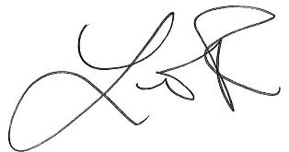
__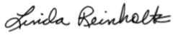_______________________________________
(Chairperson/Secretary (or Designee)
Accepted by: ______________________________________

